Nancy (Ferguson) Chalfant
November 14, 1806 – August 5, 1884

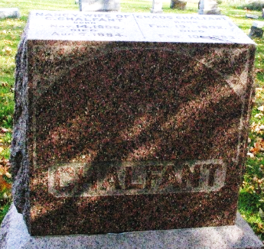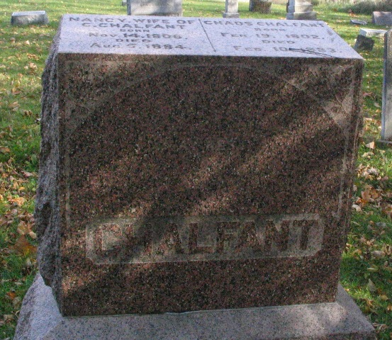
Photo by Barbara Baker Anderson

Nancy Ferguson from tree Kani-Miller Family Tree

Birth 14 Nov 1806 Bedford, Bedford, Pennsylvania, USA
Marriage 1827 Pennsylvania, USA
Residence 1880 Wells, Indiana, USA
Death 5 Aug 1884 Wells, Indiana, USA
Father JOSEPH FERGUSON (1789-1859)
Mother ELIZABETH F GLENN (1787-1854)
Spouse Chads Chalfant (1802-1883)
520 People 7 Records 20 Sources

