Mary Jane (Melick) Chalfant
December 21, 1833 – August 16, 1915

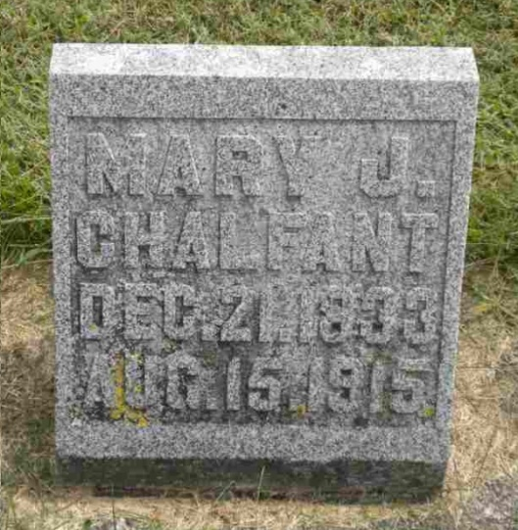
Photo by Pretty Little Grave Seekers

Mary Jane Chalfaut
in the Indiana, U.S., Death Certificates, 1899-2017

Name Mary Jane Chalfant
[Mary Jane Melick]
Gender Female
Race White
Marital Status Widowed
Age 81
Birth Date 21 Dec 1833
Birth Place Ohio
Death Date 16 Aug 1915
Death Place Harrison, Wells, Indiana, USA
Death Registration Date 1910-1919
Father Nathan Melick
Mother Mary Richey
Spouse Robert Chalfant
Informant Family; Bluffton, Indiana
Burial August 17, 1915; Bethel Cemetery

