Martha Almeda (Shuman) Chalfant
January 16, 1870 – November 10, 1930

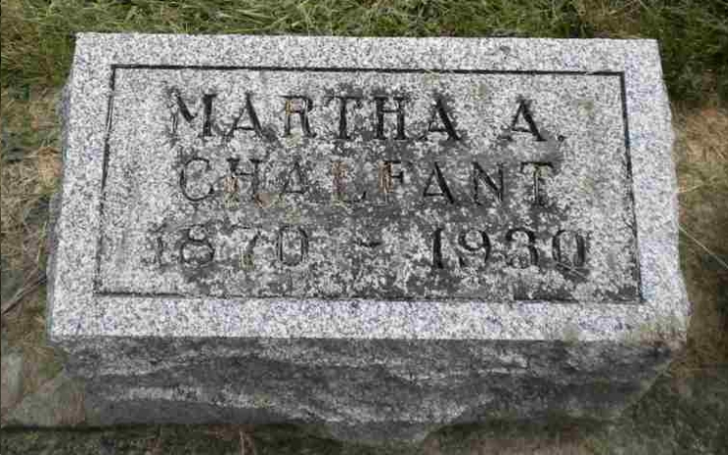
Photo by Pretty Little Grave Seekers

Martha Almeda Chalfant
in the Indiana, U.S., Death Certificates, 1899-2017

Name Martha Almeda Chalfant
[Martha Almeda Shuman]
Gender Female
Race White
Marital Status Married
Age 60
Birth Date 16 Jan 1870
Birth Place Poneto, Indiana
Death Date 10 Nov 1930
Death Place Harrison, Wells, Indiana, USA
Death Registration Date 1930
Father Joseph E. Shuman
Mother Louisa Smith
Spouse Nathan M. Chalfant
Informant Nathan Chalfant; Bluffton, Indiana
Burial November 11, 1930; Bethel Cemetery

