Catherine (Valentine) Chalfant
October 22, 1837 – February 18, 1911

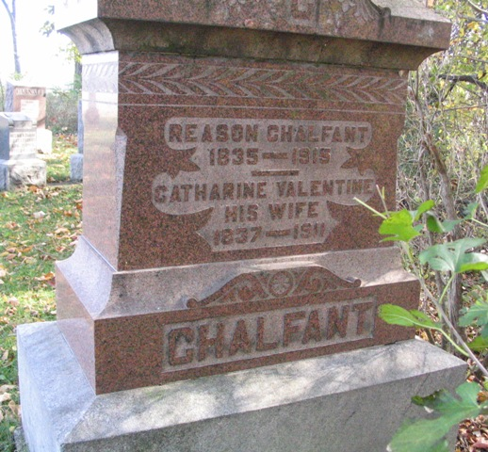
Photo by Barbara Baker Anderson

Indiana, U.S., Death Certificates, 1899-2017

Name Chatherine Chalfant
[Chatherine Valentine]
Gender Female
Race White
Marital Status Married
Age 73
Birth Date 23 Oct 1837
Birth Place Piqua Co Ohio
Death Date 18 Feb 1911
Death Place Harrison, Wells, Indiana, USA
Death Registration Date 1911
Father Joseph Valentine
Mother Sarah
Spouse Reason Chalfant
Informant Family; Bluffton, Indiana
Burial February 20, 1911; Bethel Cemetery

