Ronald Dee Carnall
April 5, 1908 – February 27, 1944

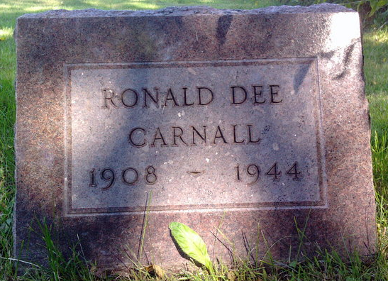
Photo by Thomas Liby

Ronald Dee Carnall
in the Indiana, U.S., Death Certificates, 1899-2017

Name Ronald Dee Carnall
Gender Male
Race White
Marital Status Married
Age 35
Birth Date 5 Apr 1908
Birth Place Harrison Twp, Wells County
Death Date 27 Feb 1944
Death Place Decatur, Adams, Indiana, USA
Death Registration Date 1944
Father David T Carnall
Mother Anna Crook
Spouse Mildred Keller
Informant Mrs. Mildred Carnall; Magley, Indiana
Burial February 29, 1944; Bethel Cemetery; Bluffton, Indiana

