Melissa C. (Higman) Carnall
January 15, 1851 – November 14, 1925

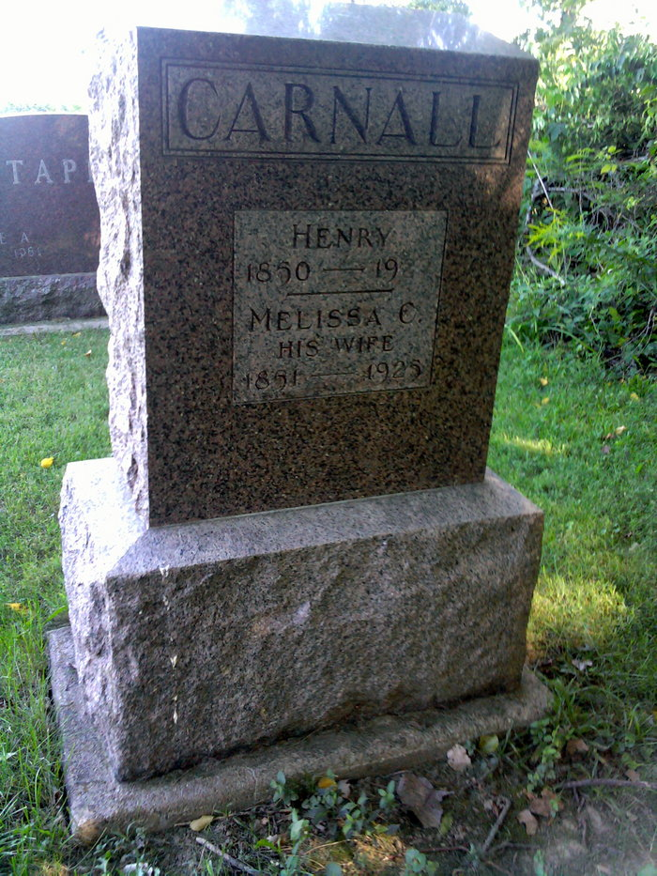
Photo by Thomas Liby

Indiana, U.S., Death Certificates, 1899-2017

Name Melissa C Carnall
[Melissa C Higman]
Gender Female
Race White
Marital Status Married
Age 74
Birth Date 15 Jan 1851
Birth Place Wells County, Indiana
Death Date 14 Nov 1925
Death Place Bluffton, Wells, Indiana, USA
Death Registration Date 1925
Father Clement Higman
Mother Unknown
Spouse Henry Carnall
Informant John Carnall; Bluffton, Indiana
Burial November 16, 1925; Bethel Cemetery
**

Malissa C Higman from tree Our Tice and Carnall Ancestry

Birth 15 Jan 1851 Wells, Indiana, USA
Marriage 23 Jul 1871 Wells, Indiana, USA
Residence 1920 Bluffton, Wells, Indiana, USA
Death 14 Nov 1925 Wells, Indiana, USA
Father Clement Ross Higman (1812-1860)
Mother Martha F Walker (1817-1888)
Spouse Henry Lawrence Carnall (1850-1927)

