Henry Carnall
February 21, 1850 – December 7, 1927

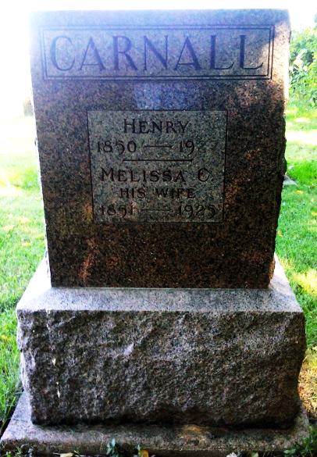
Photo by Thomas Liby

Bluffton, Ind., Dec. 7 – Henry Carnall, 77, retired farmer, father of John W. Carnall, local real estate man, died at 11 o’clock this forenoon at the county hospital here following an illness of two months. Three sons survive, John, Fred and David, all of this county.

The Star Press, Muncie, Indiana
Thursday, December 8, 1927
**

Henry Lawrence Carnall from tree Our Tice and Carnall Ancestry

Birth 21 Feb 1850 Indiana, USA
Marriage 23 Jul 1871 Wells, Indiana, USA
Residence 1920 Bluffton, Wells, Indiana, USA
Death 7 Dec 1927
Father Henry Lawrence Carnall (1823-1855)
Mother Mary Louisa Carpenter (1830-1871)
Spouse Malissa C Higman (1851-1925)

