Donald E. Carnall
August 13, 1936 – February 25, 1939

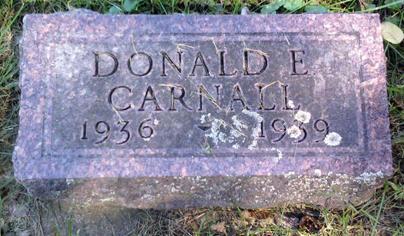
Photo by Thomas Liby

Donald E. Cornall
in the Indiana, U.S., Death Certificates, 1899-2017

Name Donald E. Carnall
Gender Male
Race White
Marital Status Single
Age 2
Birth Date 13 Aug 1936
Birth Place Celina Ohio
Death Date 25 Feb 1939; scarlet fever
Death Place Liberty, Wells, Indiana, USA
Death Registration Date 1939
Father Dee Carnall
Mother Mildred Keller
Informant Dee Carnall; Poneto, Indiana
Burial February 27, 1939; Bethel Cemetery
.

