Mary Elizabeth (Marks) Caps
January 12, 1832 – March 2, 1904

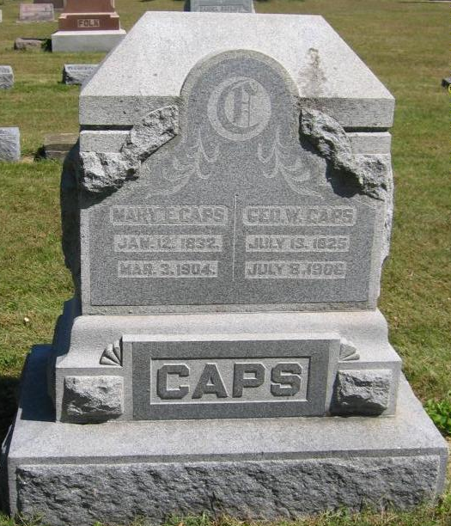
Photo by Tombstoner & Family

Mary Elizabeth Capo
in the Indiana, U.S., Death Certificates, 1899-2017

Name Mary Elizabeth Caps
[Mary Elizabeth Marks]
Gender Female
Race White
Marital Status Married
Age 72
Birth Date 12 Jan 1832
Birth Place Indiana
Death Date 3 Mar 1904
Death Place Harrison, Wells, Indiana, USA
Death Registration Date 1904
Father Jacob Marks
Mother Elizabeth Shaffer
Spouse Wm Caps
Informant Geo. Caps; Bluffton, Indiana
Burial March 6, 1904; Bethel Cemetery

