George William Caps
July 13, 1825 – July 8, 1906

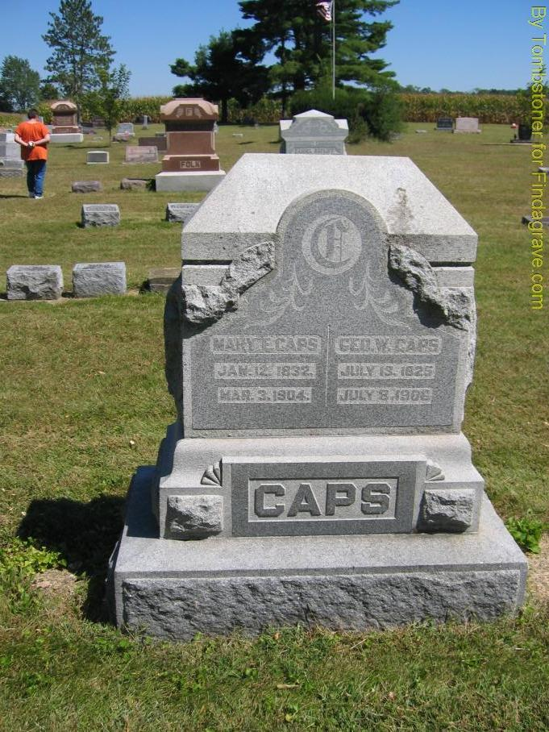
Photo by Tombstoner & Family

George Wm Caps
in the Indiana, U.S., Death Certificates, 1899-2017

Name George Wm Caps
Gender Male
Race White
Marital Status Widowed
Age 80
Birth Date 13 Jul 1825
Birth Place Germany
Death Date 8 Jul 1906
Death Place Harrison, Wells, Indiana, USA
Death Registration Date 1906
Father Christopher Caps
Mother Edna Wertenberger
Spouse Elizebeth
Informant Family; Bluffton, Indiana
Burial July 11, 1906; Bethel Cemetery

