Francis Burris
March 5, 1836 – April 21, 1884

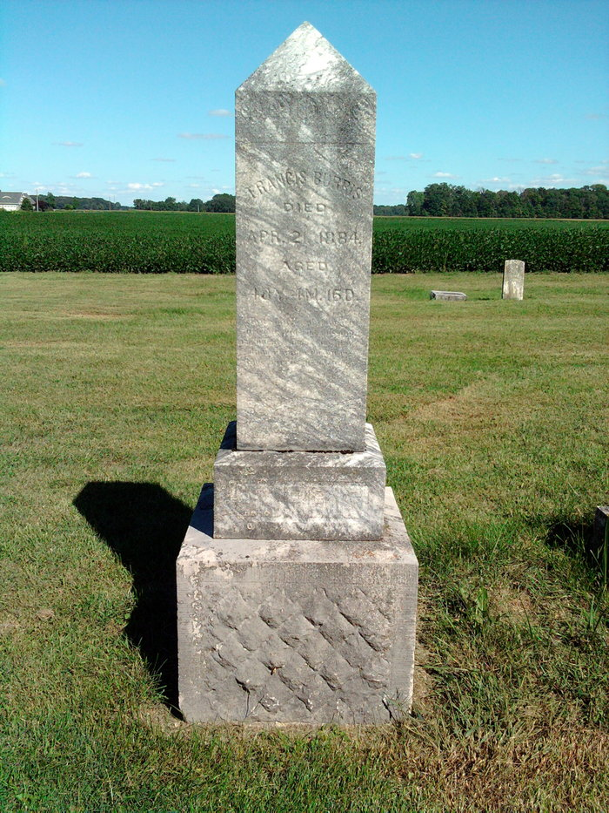
Photo by Thomas Liby

Francis Burris from tree Hice Family Tree

Birth 5 Mar 1836 Ohio, USA
Marriage 12 Aug 1860 Wells, Indiana, USA
Residence 1870 Wells, Indiana, USA
Death 21 Apr 1884 Bluffton, Wells, Indiana, USA
Spouse Nancy Margaret Popejoy (Burris) (Schmale) (1839-1913)
7356 People 6 Records 7 Sources

