John Burgess
February 16, 1853 – January 16, 1855

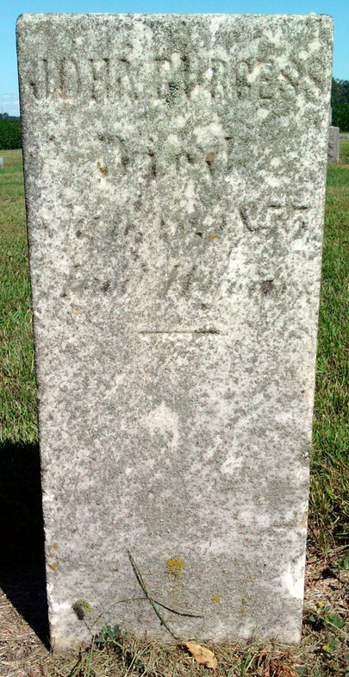
Photo by Thomas Liby

No further information found at this time.

