Matilda Frances (Fox) Buckles
October 10, 1856 – September21, 1888

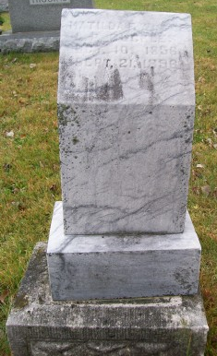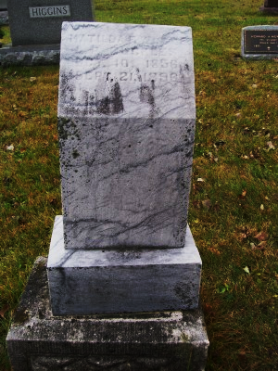
Photo by Scott Shoup

Matilda Francis Fox from tree Snyder Family Tree

Birth 10 Oct 1856 Augusta, Virginia, USA
Death 21 Sep 1896 Wells, Indiana, USA
Father John FOX
Mother Eveline
Spouse Leander Perkins Buckles (1852-1934)
375 People 1 Record 6 Sources

