Lewis D. Buckles
December 10, 1818 – December 8, 1907

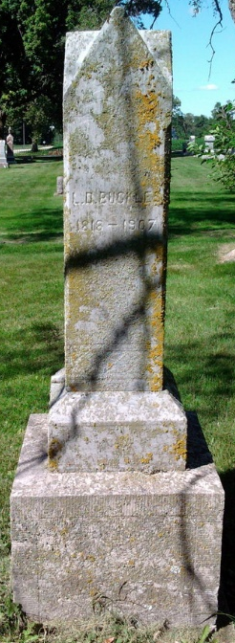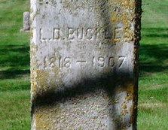
Photo by Thomas Liby

Lewis D Buckles
in the Indiana, Death Certificates, 1899-2011

Name: Lewis D Buckles
Gender: Male
Race: White
Age: 88
Marital Status: Widowed
Birth Date: 10 Dec 1818
Birth Place: Ohio
Death Date: 8 Dec 1907
Death Place: Harrison, Wells, Indiana, USA
Father: James Buckles
Mother: Sarah Perkins
Spouse: Elizabeth Flowers
Informant: Chas. Buckles; Bluffton, Ind.
Burial: Dec. 9, 1907 Bethel Cem.

