Alva M. Brown
January 22, 1865 – December 7, 1940

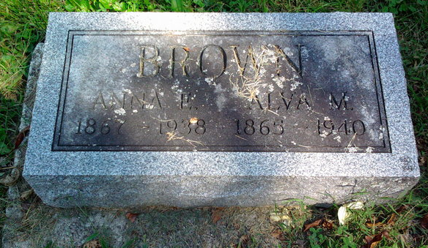
Photo by Thomas Liby

Alva M Brown
in the Indiana, U.S., Death Certificates, 1899-2017

Name Alva M Brown
Gender Male
Race White
Marital Status Widowed
Age 75
Birth Date 22 Jan 1865
Birth Place Indiana
Death Date 7 Dec 1940
Death Place Rural, Wayne, Indiana, USA
Death Registration Date 1940
Father Absolom Brown
Mother Mary Dorsey
Informant Richmond State Hospital records; Richmond, Indiana
Burial December 9, 1940; Bethel Cemetery; Wells County, Indiana

**
H. Brown & Son Funeral Home record

Brown, Alva M.
B. 22 Jan 1855 Clinton Co., IN. D. 7 Dec 1940 Wells Co., IN.
bur. Bethel Cem. Wells Co.
Fa. A. S. Brown. Mo. Mary Dorsey
M. 29 Oct 1889 Anna Wrightsman.
Ch. Mrs. Otto Hamilton & Mrs. Leslie Hamilton

