Sarah Catherine (Brown) Brinneman
January 26, 1878 – September 4, 1939

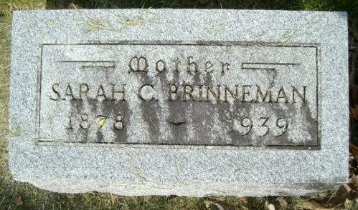
Photo by smalltown

Sarah Katherine Brinneman
in the Indiana, U.S., Death Certificates, 1899-2017

Name Sarah Katherine Brinneman
[Sarah Katherine Brown]
Gender Female
Race White
Marital Status Widow
Age 61 years, 7 months, 8 days
Birth Date 1 Jan 1878
Birth Place Wells County, Indiana
Death Date 4 Sep 1939
Death Place Bluffton, Wells, Indiana, USA
Father Solomon Brown
Mother Hannah Haflich
Spouse Augustus Brinneman
Informant Loyd Romine; Bluffton, Indiana
Burial September 6, 1939; Bethel Cemetery; Wells County

**
Indiana, U.S., Marriages, 1810-2001

Name Sarah Catherine Romine [Sarah Catherine Brown]
Gender Female
Race White
Age 37
Event Type Marriage Registration (Marriage)
Birth Date 26 Jan 1879
Birth Place Wells, Indiana
Marriage Date 2 Jun 1916
Marriage Place Indiana, United States
Residence Place Bluffton, Indiana
Father Solomon Brown
Mother Hanna Brown
Spouse Augustus Brineman
Page 105
FHL Film Number 002318975

