Augustus Brinneman
March 9, 1879 – September 30, 1930

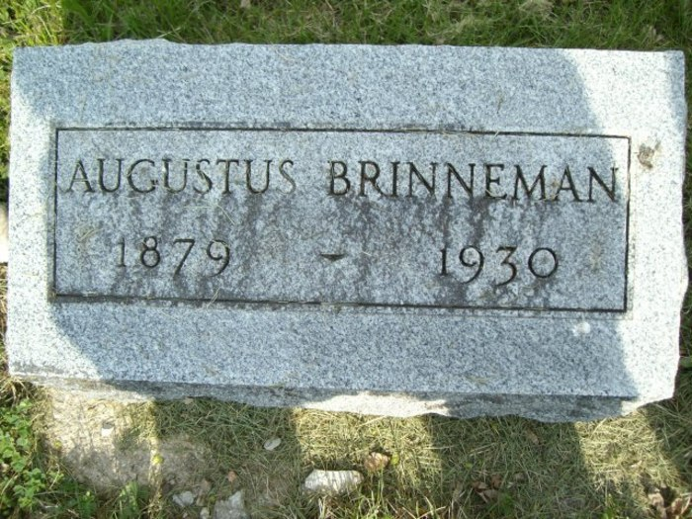
Photo by smalltown

Augustus Newton Brinneman
in the Indiana, U.S., Death Certificates, 1899-2017

Name Augustus Newton Brinneman
Gender Male
Race White
Marital Status Married
Age 51
Birth Date 9 Mar 1879
Birth Place Wells County, Indiana
Death Date 30 Sep 1930
Death Place Bluffton, Wells, Indiana, USA
Death Registration Date 1930
Father Jefferson Brinneman
Mother Sarah Glass
Spouse Sarah Brown
Informant Mrs. Augustus Brinneman; Bluffton, Indiana
Burial October 2, 1930; Bethel Cemetery

