Carolyn Jean (Davis) Bracht
June 2, 1940 – February 28, 2013

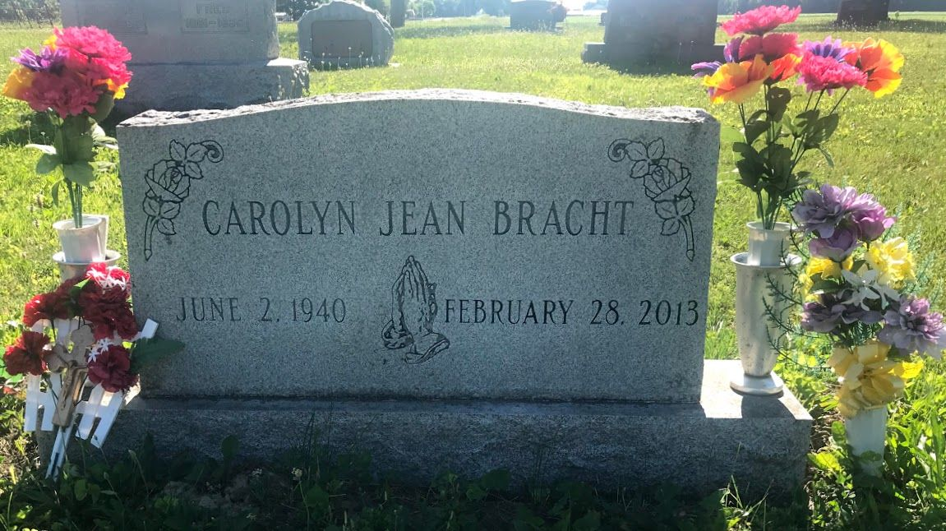
Photo by SMMR

Carolyn J. Bracht, 72, of Bluffton, died at 7:30 a.m. Thursday, Feb. 28, 2013, at the Bluffton Regional Medical Center. She died after a 46-year battle with multiple sclerosis. She was born June 2, 1940, in Petroleum, to Wayne K. Davis and Eva A. Ripple Davis. Carolyn was a homemaker and had resided at Kindred Nursing and Rehabilitation-Meadowvale for 29 years. She was a 1958 graduate of Petroleum High School and a member of the First Church of Christ in Bluffton. She enjoyed playing cards and bingo.
Survivors include two sons, Scott A. Bracht and Steve R. (Tina) Bracht, both of Bluffton; a grandson, Cody J. Bracht of Bluffton; a sister, Connie S. Edris of Bluffton; a nice, Kelly Peterson of Bluffton; a nephew, Todd Edris of Bluffton; two great-nephews, Tyler Peterson and Colton Edris, both of Bluffton; an aunt, Martha E. Bordner, who resides in North Carolina; and a good friend and cousin, Sherryl Nicholson of Uniondale. She was preceded in death by an infant daughter and by a brother-in-law, Max L. Edris.
A funeral service will be held at 2 p.m. Sunday, March 3, at the Goodwin-Cale and Harnish Memorial Chapel in Bluffton with Larry Sprinkle officiating. There will be calling from 5 to 8 p.m. Friday, noon to 6 p.m. Saturday, and from 1 to 2 p.m. Sunday at the funeral home. Burial will be at the Bethel Cemetery.
Preferred memorials are to the Kindred Nursing and Rehabilitation-Meadowvale facility or to the First Church of Christ in Bluffton.

Goodwin Funeral Homes online obit (accessed March 1, 2013)

