Nancy Ellen Bower
February 16, 1936 – July 28, 1937

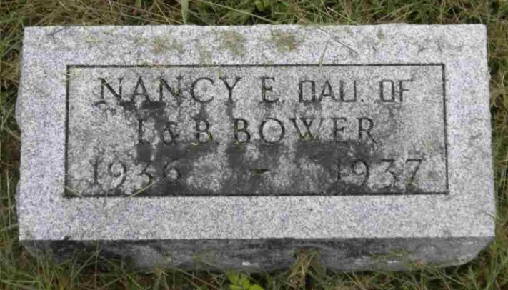
Photo by Pretty Little Grave Seekers

Nancie Ellen Bower
in the Indiana, U.S., Death Certificates, 1899-2017

Name Nancie Ellen Bower
Gender Female
Race White
Marital Status Single
Age 1 year, 5 months
Birth Date abt 1936
Birth Place Muncie, Indiana
Death Date 28 Jul 1937
Death Place Parker City, Randolph, Indiana, USA
Death Registration Date 1937
Father Orenus Bower
Mother Bertha Strain
Informant Orenus Bower; Parker, Indiana
Burial July 30, 1937; Bethel Cemetery; Wells County
**

Indiana, U.S., Birth Certificates, 1907-1944

Name Nancy Ellen Bower
Gender Female
Birth Date 16 Feb 1936
Birth Place Muncie, Delaware, Indiana, USA
Father Irenus Bower; age 45
Mother Bertha Strain; age 40; 8th child; all living
Certificate Number 5282
Roll number 40474_357219
Volume Range 11 - 15

