Mary Ann (Shepherd) Bayman
February 9, 1824 – September 10, 1863

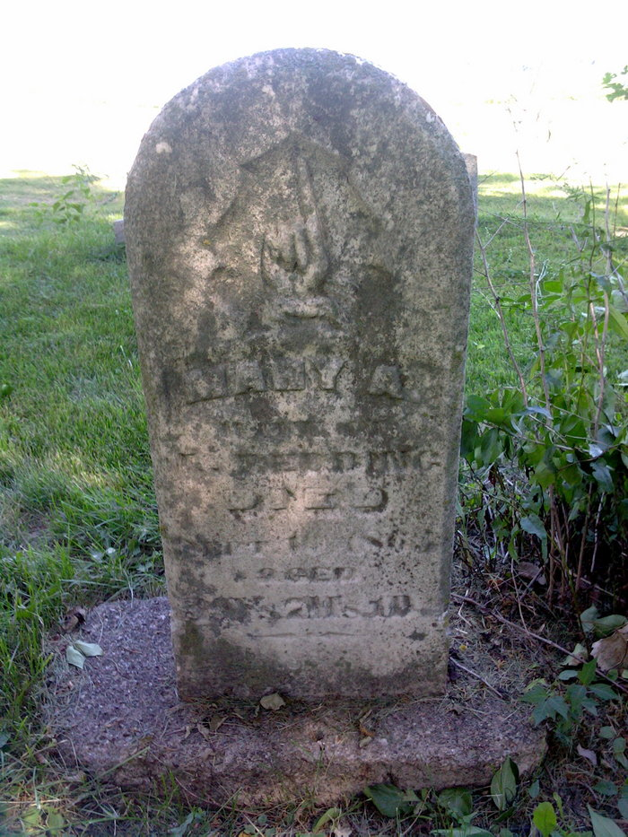
Photo by Thomas Liby

No further information found at this time.

