Andrew Bayman
March 21, 1816 – November 3, 1847

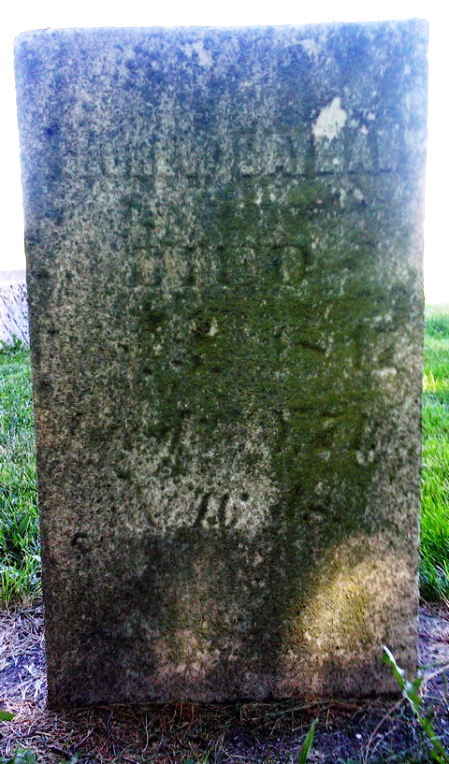
Photo by Thomas Liby

Andrew Bayman from tree Todd Jason Brown Family Tree

Birth 21 Mar 1816
Marriage 26 Nov 1840 Bluffton, Wells, Indiana, USA
Death 3 Nov 1847 Wells, Indiana, USA
Father William Bayman (Born 1792)
Mother Mariah Kindle
Spouse Mary Ann Shepherd (1824-1863)

