Randy Joe Aschliman
May 26, 1977 – January 1, 1987

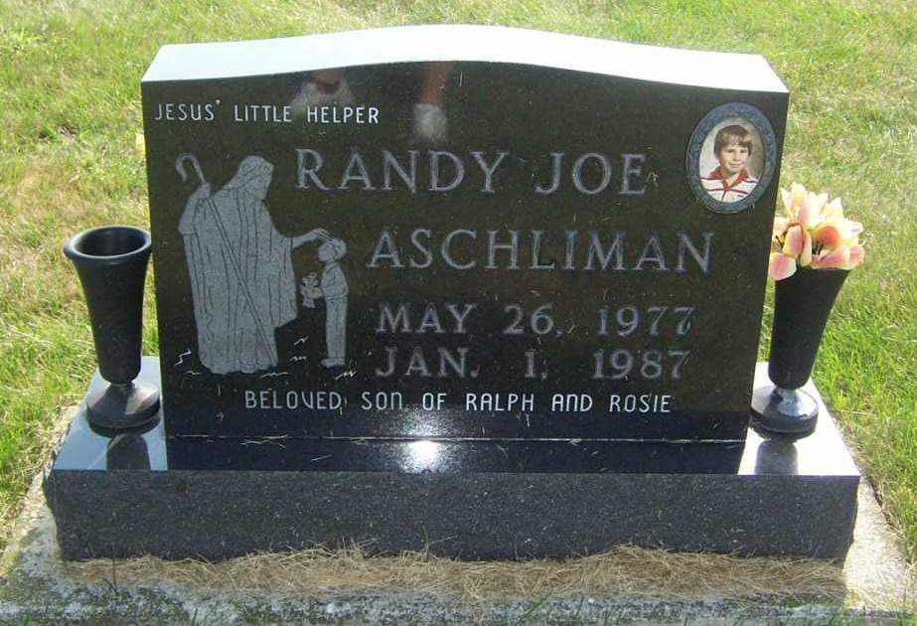
Photo by Pretty Little Grave Seekers

Randy Joe Aschliman
in the Indiana, U.S., Death Certificates, 1899-2017

Name Randy Joe Aschliman
Gender Male
Race White
Marital Status Single
Age 9
Birth Date 26 May 1977
Birth Place Indiana
Death Date 1 Jan 1987
Death Place Bluffton, Wells, Indiana, USA
Death Registration Date 1987
Father Ralph Aschliman
Mother Rosie Lehrman
Informant Ralph Aschliman; father; Decatur, Indiana
Burial January 3, 1987; Apostolic Church Cemetery; Vera Cruz, Indiana

