Carson Alexander
1826 - 1883

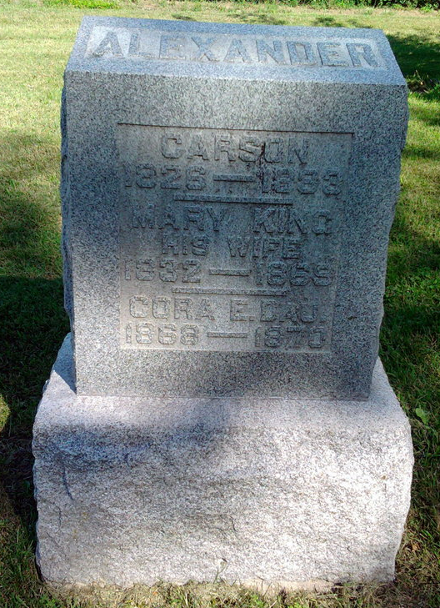
Photo by Thomas Liby

CARSON Alexander from tree YatesDelfosse

Birth 1826 Muskingum, Ohio, USA
Marriage 21 Aug 1849 Perry, Ohio, USA
Residence 1880 Wells, Indiana, USA
Death 28 Oct 1883 Wells, Indiana, USA
Father Isaac Alexander (1800-1867)
Mother Elisa Strickler (1805-1870)
Spouse Mary King (1832-1869)
2163 People 9 Records 18 Sources

