Homer S. Addington
May 10, 1890 – March 29, 1987

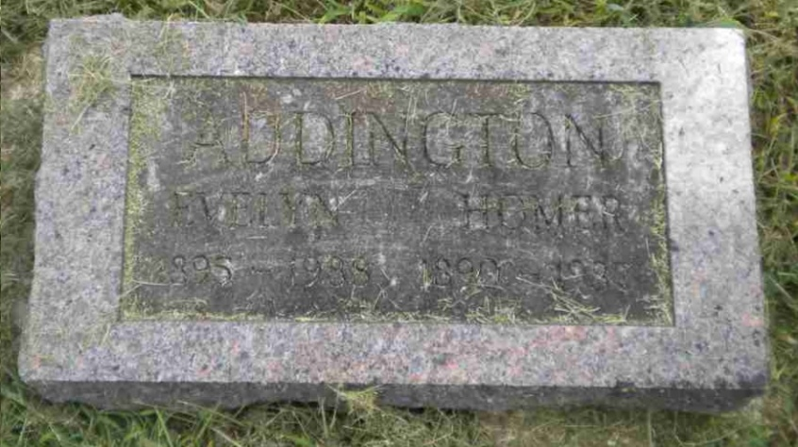
Photo by Pretty Little Grave Seekers

Homer S Addington
in the Indiana, U.S., Death Certificates, 1899-2017

Name Homer S Addington
Gender Male
Race White
Marital Status Married
Age 96
Birth Date 10 May 1890
Birth Place Indiana
Death Date 29 Mar 1987
Death Place Bluffton, Wells, Indiana, USA
Death Registration Date 1987
Father Alvis Patton Addington
Mother Sarah Dutten
Spouse Evelyn Harriet Ratliff
Informant Evelyn Addington; wife; Bluffton, Indiana
Burial April 1, 1987; Bethel Cemetery; Bluffton, Indiana

