Evelyn (Ratliff) Addington
December 10, 1895 – September 25, 1988

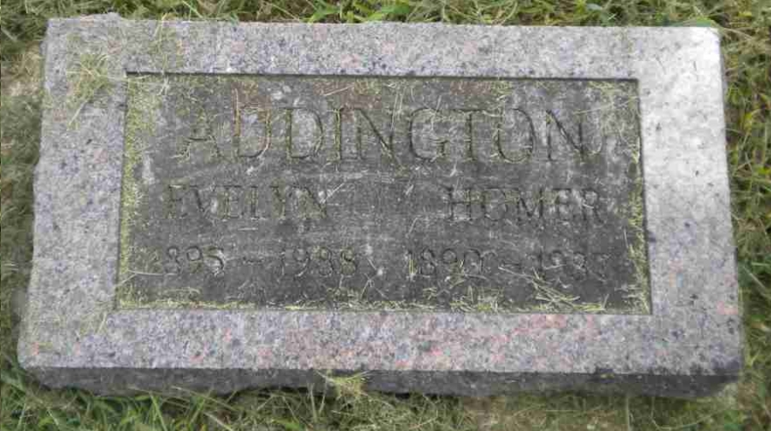
Photo by Pretty Little Grave Seekers

Evelyn H Addington
in the Indiana, U.S., Death Certificates, 1899-2017

Name Evelyn H Addington
[Evelyn H Ratliff]
Gender Female
Race White
Marital Status Widowed
Age 92
Birth Date 10 Dec 1895
Birth Place Wells County, Indiana
Death Date 25 Sep 1988
Death Place Bluffton, Wells, Indiana, USA
Death Registration Date 1988
Father John Ratliff
Mother Dora Caps
Informant Esther Lockwood; daughter; Bluffton, Indiana
Burial September 29, 1988; Bethel Cemetery; Bluffton, Indiana

