May (Compton) Williams
November 7, 1875 – June 9, 1897

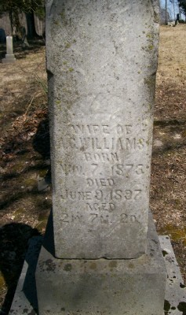
Photo by Scott Shoup
Death of May Williams
May Compton, wife of Aurelius C. Williams, and daughter of Henry and Sarah Compton was born Nov. 7, 1875 and died June 9, 1897, aged 21 years, 7 months and 2 days. She was married to Aurelius Williams April 16, 1896. She leaves a companion, mother, three brothers, a sister and other numerous relatives and acquaintances to mourn her departure.
May was a loving daughter and companion, but was taken away from earth in youth. But the old must die and the young may die. Her place is now vacant in Sunday School, church and in the circles of young associates which can never be filled. Rev. Huffman preached the funeral discourse at two o'clock, Thursday, June 10, at the Dunkard church, and interment was in the Batson Cemetery.
Warren Republican, July 1, 1897

