George C. White
September 22, 1847 – January 25, 1902

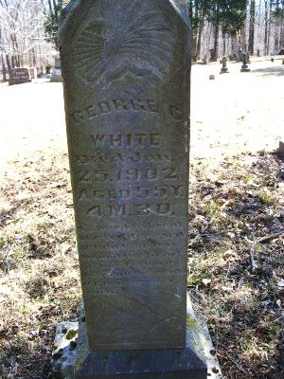
Photo by Scott Shoup
George C. White
in the Indiana, Death Certificates, 1899-2011

Name: George C White
Gender: Male
Race: White
Age: 54y 4m 3d
Marital status: Married
Birth Date: 22 Sep 1847
Birth Place: Ind
Death Date: 25 Jan 1902
Death Place: Chester, Wells, Indiana, USA
Father: Joel White
Mother: Betsy Garretson
Spouse: Lavina White
Informant: Frank White of Mt. Zion, Ind
Burial: Jan. 22, 1902; Batson Cemetery

