Genettie L. (Williams) Parker
May 16, 1855 – July 7, 1899

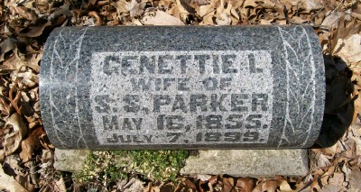
Photo by Scott Shoup
Nettie I Williams
in the Indiana, Marriages, 1810-2001

Name: Nettie I Williams
Gender: Female
Event Type: Marriage Registration (Marriage)
Marriage Date: 9 Oct 1886
Marriage Place: Indiana, United States
Spouse: Simeon S Parker
Page: 567
FHL Film Number: 002318463

