Israel Horner
September 15, 1864 – June 16, 1934

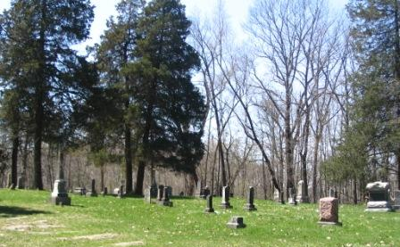
Photo by Barbara Baker Anderson

Israel Horner
in the Indiana, Death Certificates, 1899-2011

Name: Israel Horner
Gender: Male
Race: White
Age: 69y 9m 1d
Marital status: Single
Birth Date: 15 Sep 1864
Birth Place: Wells Co., Ind.
Death Date: 16 Jun 1934
Death Place: Harrison, Wells, Indiana, USA
Father: -- Davis
Mother: Pheobe Horner
Informant: [smudged] Horner of Gas City, Ind
Burial: June 18, 1934; Batson Cemetery

