Nora E. (Good) Fix
April 20, 1865 – May 6, 1892

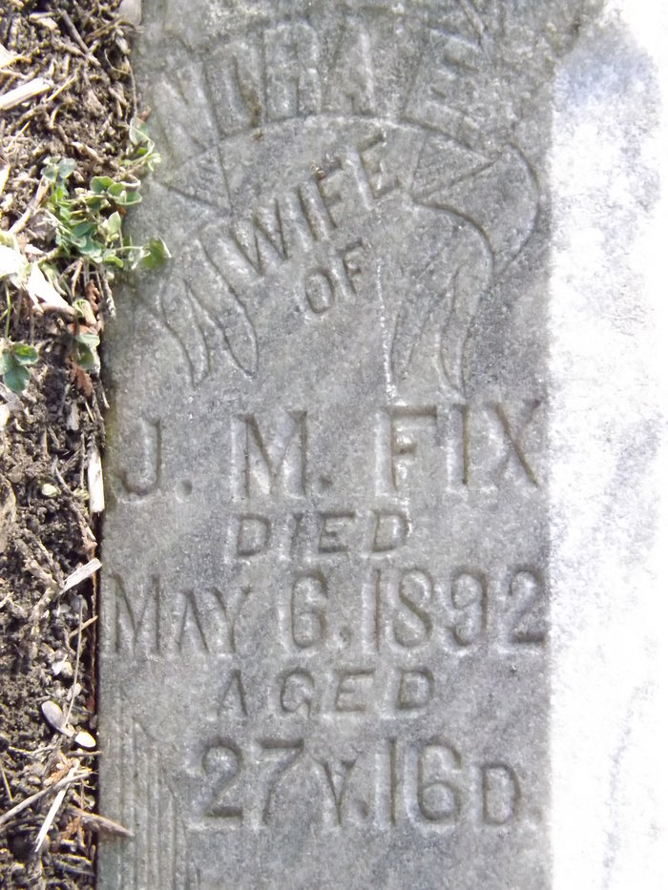
Photo by James Allen

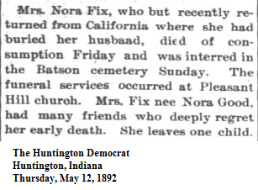
Contributed by OOPSheryl

