Lydia (Baker) Fix-Knott
September 9, 1839 – August 24, 1915

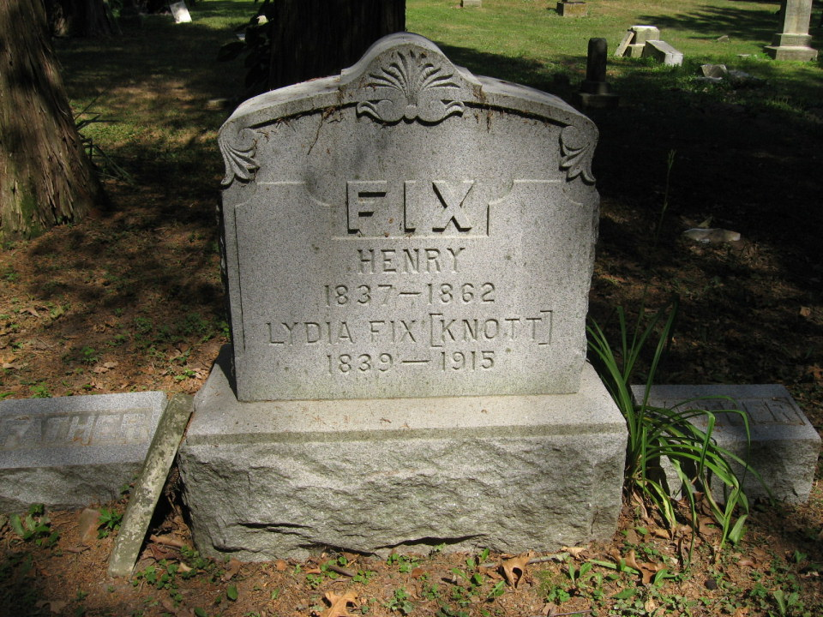
Photo by Tombstoner & Family

Lydia Knott
in the Indiana, Death Certificates, 1899-2011

Name: Lydia Knott
[Lydia Baker]
Gender: Female
Race: White
Age: 74y 11m 15d
Marital status: Married
Birth Date: 9 Sep 1840
Birth Place: Ohio
Death Date: 24 Aug 1915
Death Place: Jackson, Wells, Indiana, USA
Father: John Baker
Mother: Susannah Hower
Spouse: John Knott, informant
Burial: Aug 26, 1915; Batson Cemtry

