Sarah Dell (Cloud) Dillman
February 19, 1852 – October 5, 1935

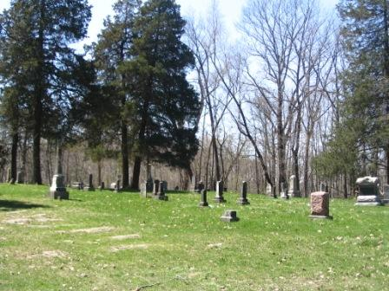
Photo by Barbara Baker Anderson

Former Dillman Woman Passes at Daughters

Mrs. Sarah D. Dillman, 83, died at 3:30 Saturday afternoon of complications at the home of her daughter, Mrs. Josie Benson, at Frayzeburg, Ohio, where she was visiting when she became ill.
Born in Jackson Township, Wells County on Feb. 18, 1852, Mrs. Dillman was a daughter of Carson and Rebecca Jones Cloud.
Her marriage to John E. Dillman took place on Dec. 30, 1877. He preceded her in death.
Surviving are 7 children, Homer and Thomas Dillman, Tampa, Texas; Mrs Josie Benson, Frayzeburg, Ohio; Mrs. Mary Mercer, Coweta, Okla.; Mrs. Almeda Johnson, Peterson; Mrs. Virgil (*should be Virgie) Tucker, Oklahoma City; and Mrs. Hazel Paugh, Columbus, Ohio.
Funeral services were held at 2 o'clock Tuesday (*10 Oct 1935) afternoon at the Union chapel M.E. Church in Jackson Twp. in charge of Rev. Miller, Of Hanfield. Burial in the Batson Cemetery.

Van Buren News-Eagle, Grant County, IN; October 10, 1935

