Benjamin Clark Batson
November 14, 1847 – September 12, 1921

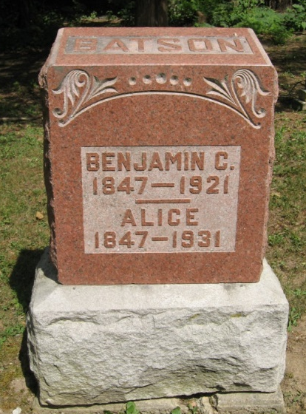
Photo by Tombstoner & Family

Jackson Twp. Pioneer Is Called To Reward
Benjamin Batson, 73, Died At His Home Near Mt. Zion This Morning
Benjamin Batson, a pioneer resident of Jackson Township, died at 3:30 o'clock this morning at his home one mile south and one mile west of Mt. Zion at the age of seventy-three years nine months and twenty-nine days. Mr. Batson had been in feeble health for some time, but the end was hastened when he was stricken with pneumonia last Thursday. Mr. Batson was born on the farm on which he died. He was one of nine children son of Nathaniel Batson and Nancy Ralston, and his parents and all brothers and sisters have preceded him in death.
Surviving are the widow; one son Henry Batson, and a daughter, Mrs. Ollie Dawson, residing near Montpelier. An infant son died many years ago, and another son, James, died two years ago.
The deceased was a member of the Church of the Brethren at Sugar Grove, and the funeral service will be held there at 2 Wednesday afternoon, with interment in the Batson Cemetery.

Bluffton Evening News, Wells County, IN; September 12, 1921

