Clara Cecelia (Kuttler) Kitterman
February 19, 1895 – November 1, 1994

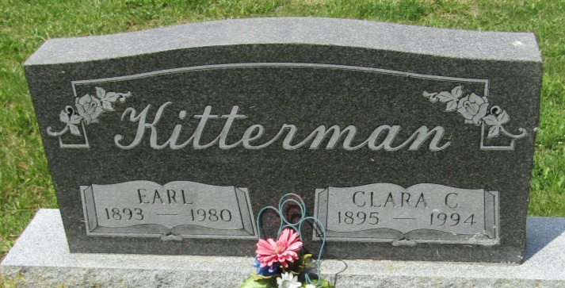
Clara Cecelia Kitterman
in the Indiana, U.S., Death Certificates, 1899-2011
Name: Clara Cecelia Kitterman
[Clara Cecelia Kuttler]
Gender: Female
Race: White
Age: 99
Marital status: Widowed
Birth Date: 19 Feb 1895
Birth Place: Blackford County
Death Date: 1 Nov 1994
Death Place: Hartford, Blackford, Indiana, USA
Father: Jacob Kuttler
Mother: Ila Bell Capper
Informant: James Kitterman; cousin; Hartford City, Indiana
Burial: November 4, 1994; Asbury Cemetery; Wells County, Indiana

