Henry Otho Ketring
October 14, 1878 – October 24, 1951

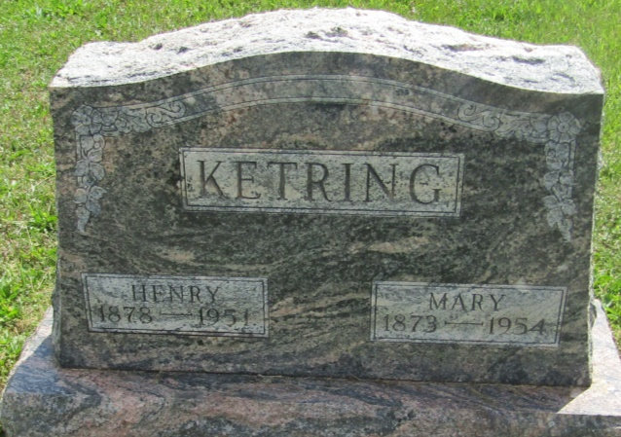

Henry Otho Ketring
in the Indiana, U.S., Death Certificates, 1899-2011
Name: Henry Otho Ketring
Gender: Male
Race: White
Age: 73
Marital status: Married
Birth Date: 14 Oct 1878
Birth Place: Ohio
Death Date: 24 Oct 1951
Death Place: Van Buren, Grant, Indiana, USA
Father: George Ketring
Mother: Butts
Informant: Mrs. Henry Ketring
Burial: October 26, 1951; Asbury Chapel Cemetery; Blackford County

