Roy J. Kelly
January 21, 1880 – February 14, 1967

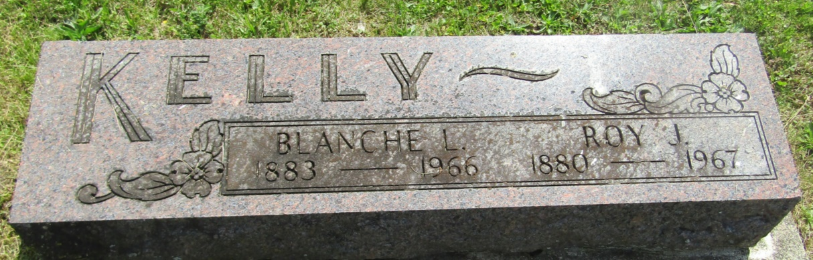

Roy J Kelly
in the Indiana, U.S., Death Certificates, 1899-2011
Name: Roy J Kelly
Gender: Male
Race: White
Age: 87
Marital status: Widowed
Birth Date: 21 Jan 1880
Birth Place: Pleasantville, PA
Death Date: 14 Feb 1967
Death Place: Warren, Huntington, Indiana, USA
Father: Flint Kelly
Mother: Clara M Baker
Informant: Dr. Dewey Souder; guardian; Warren, Indiana
Burial: February 16, 1967; Asbury Cemetery; Wells County, Indiana

