Lewis Johnson
August 21, 1900 – August 10, 1903

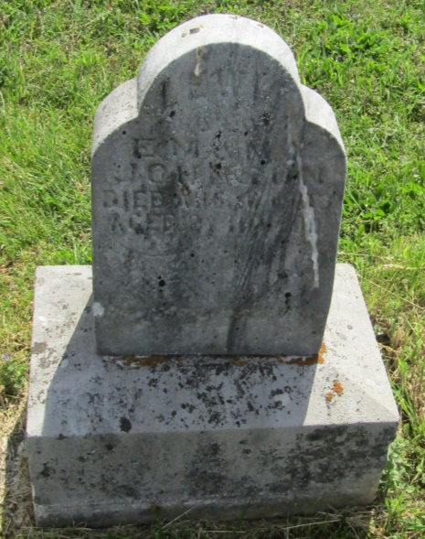

Lewis Johnson
in the Indiana, U.S., Death Certificates, 1899-2011
Name: Lewis Johnson
Gender: Male
Race: White
Age: 2
Birth Date: 21 Aug 1900
Birth Place: Indiana
Death Date: 10 Aug 1903; accidently run over by wagon
Death Place: Washington, Blackford, Indiana, USA
Father: Eli W Johnson
Mother: Meltilda Fleming
Informant: Eli Johnson; Roll, Indiana
Burial: August 11, 1903; Washington Township cemetery

