Eli M. Johnson
November 7, 1859 – April 17, 1928

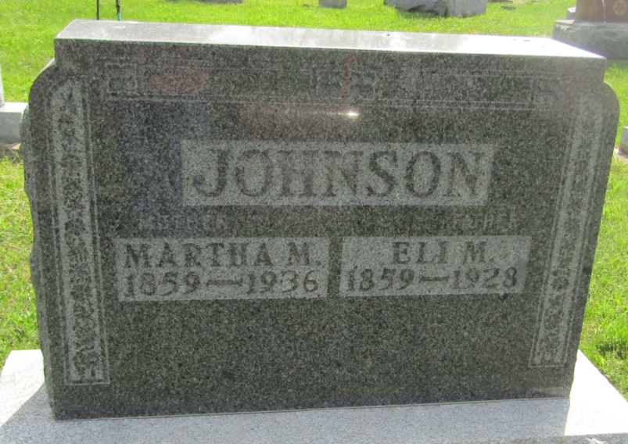

Eli M. Johnson
in the Indiana, U.S., Death Certificates, 1899-2011
Name: Eli M. Johnson
Gender: Male
Race: White
Age: 68
Marital status: Married
Birth Date: 7 Nov 1859
Birth Place: Ind.
Death Date: 17 Apr 1928
Death Place: Hartford City, Blackford, Indiana, USA
Father: John M Johnson
Mother: Eliza Woolery
Spouse: Martha
Informant: Chas A. Johnson; Montpelier, Indiana
Burial: April 20, 1928; Asbury Chapel

