Dora Ellen (Ketering) Johnson
November 20, 1880 – March 25, 1960

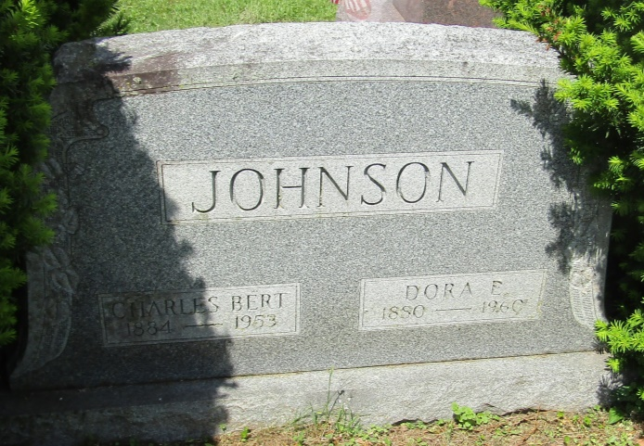

Dora Ellen Johnson
in the Indiana, U.S., Death Certificates, 1899-2011
Name: Dora Ellen Johnson
[Dora Ellen Ketering]
Gender: Female
Race: White
Age: 79
Marital status: Widowed
Birth Date: 20 Nov 1880
Birth Place: Indiana
Death Date: 25 Mar 1960
Death Place: Hartford, Blackford, Indiana, USA
Father: George Ketering
Mother: Ellen Butts
Informant: Earl Kitterman; nephew; Hartford City, Indiana
Burial: March 29, 1960; Asbury Cemetery; Wells County, Indiana

