Minnie Olive (Leonard) Jarrett
October 3, 1882 – January 11, 1969

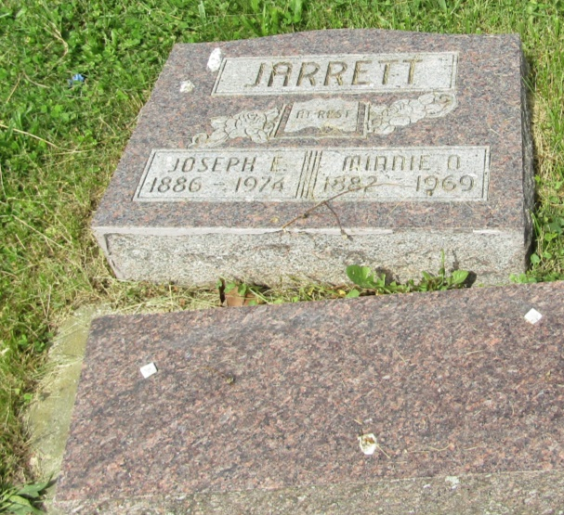

Minnie Olive Jarrett
in the Indiana, U.S., Death Certificates, 1899-2011

Name: Minnie Olive Jarrett
[Minnie Olive Leonard]
Gender: Female
Race: White
Age: 86
Marital status: Married
Birth Date: 3 Oct 1882
Birth Place: Indiana
Death Date: 11 Jan 1969
Death Place: Hartford, Blackford, Indiana, USA
Father: William Leonard
Mother: Sarah Chapel
Spouse: Joseph E Jarrett
Informant: Joseph E. Jarrett; husband; Montpelier, Indiana
Burial: January 14, 1969; Asbury Cemetery; Wells County, Indiana

