William Henry Hunnicutt
September 17, 1884 – July 27, 1974

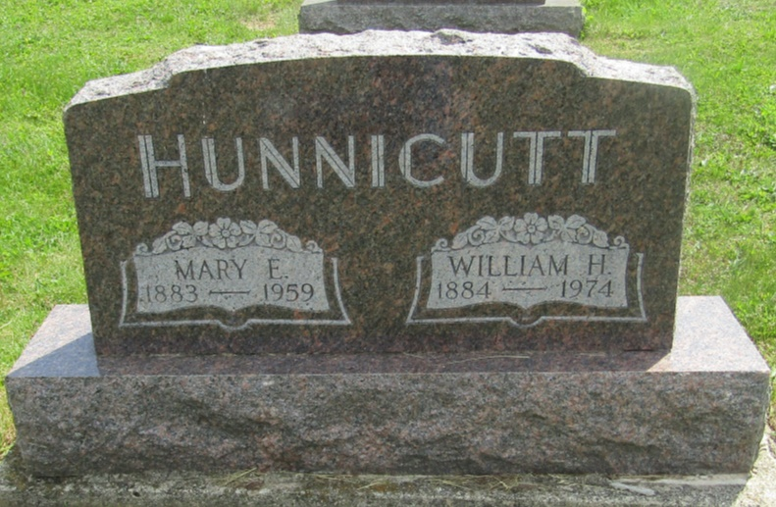

William Henry Hunnicutt
in the Indiana, U.S., Death Certificates, 1899-2011
Name: William Henry Hunnicutt
Gender: Male
Race: White
Age: 89
Marital status: Widowed
Birth Date: 17 Sep 1884
Birth Place: Indiana
Death Date: 27 Jul 1974
Death Place: Hartford, Blackford, Indiana, USA
Father: William H Hunnicutt
Mother: Rachel Bradfield
Informant: Russell Hunnicutt; son; Montpelier, Indiana
Burial: July 30, 1974; Asbury Cemetery; Montpelier, Indiana

