Serepty Howe
1851 – July 11, 1863

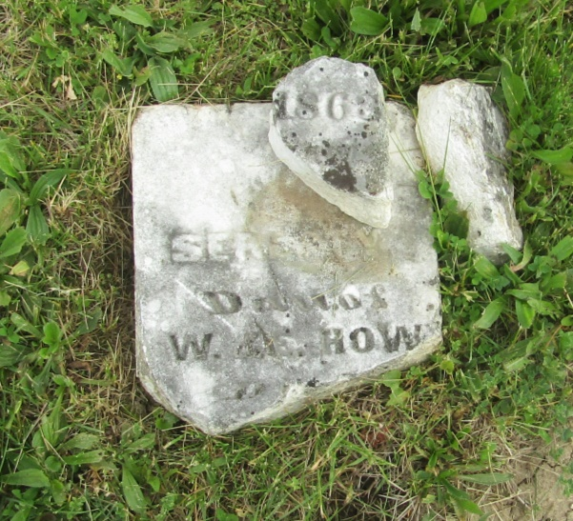

No further information found at this time

