Nathan D. Hodgson
March 25, 1816 – October 20, 1868

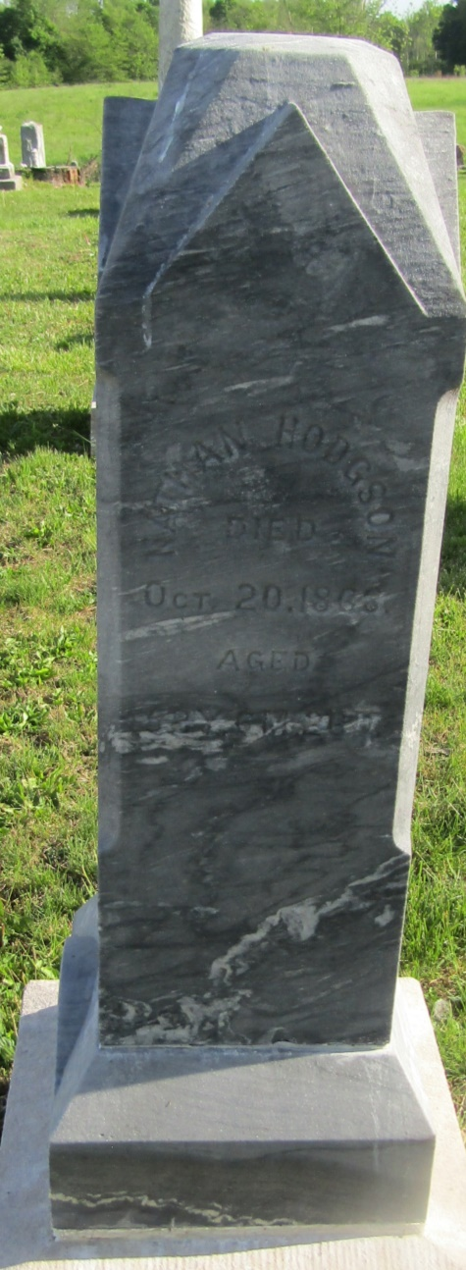

No further information found at this time

