Elizabeth Ratcliffe (Wollary) Hodgson
October 25, 1818 – August 5, 1887

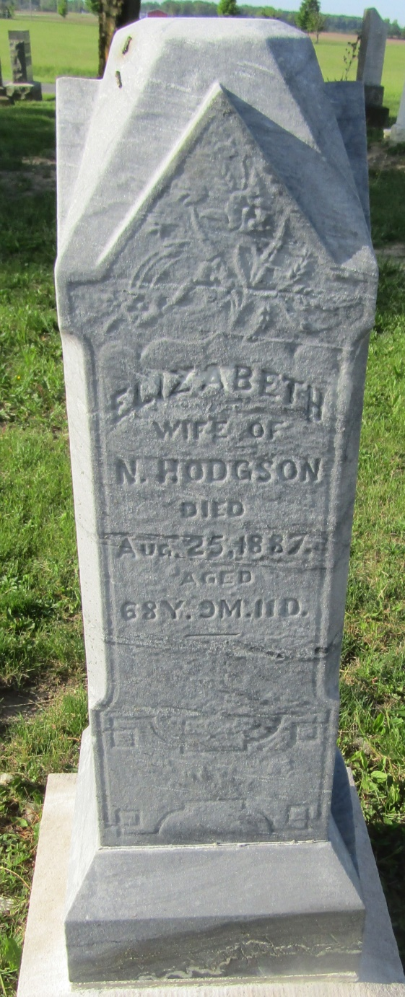

No further information found at this time

