Lena Ruth (Booher) Herring
July 5, 1920 – September 4, 2010

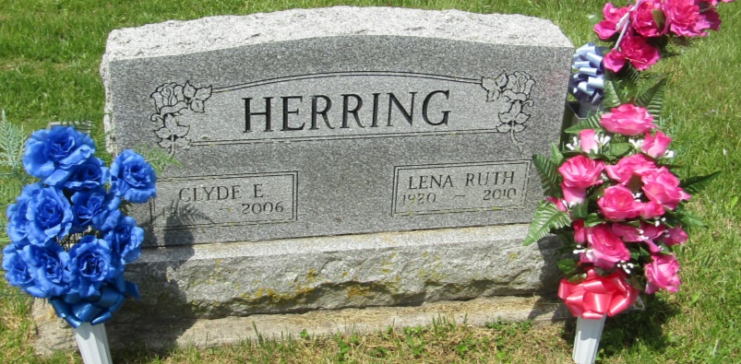

WARREN -- Ruth Herring, 90, of Jackson Township , rural Warren, passed away at 8:17 a.m. Saturday with family by her side.
Mrs. Herring was born on, July 5, 1920, in Jackson Township. She was the daughter of the late John Booher and the late Alice (Thrailkill) Booher. She married Clyde Herring on Oct. 10, 1942 in Bluffton, he preceded her in death on March 6, 2006.
Mrs. Herring was a homemaker. She had also helped her husband with woodcrafts.
She is survived her sons, Bob (Jan) Herring, Bluffton, Gary (Vicki, La Fontaine; daughters, Joyce (Larry) Luckey, Jackson Township, Sherri (Don) Carroll, Jackson Township; sisters, Amy Runkle, Warren, Betty Marshall, Bluffton; nine grandchildren; 13 great-grandchildren; and two great-great-grandchildren.
She was preceded in death by her husband, Clyde Herring; father, John L. Booher; mother, Alice (Thrailkill) Booher; and brothers, Virgil and Billy Booher.
Services are at 11 a.m. Thursday in the Glancy - H. Brown & Son Funeral Home, 203 N. Matilda St., Warren, with Rev. Dewey Zent officiating. Interment will be at the Asbury Cemetery in Jackson Township, Wells County. Visitation is from 2 to 8 p.m. Wednesday and from 10 to 11 a.m. Thursday in the funeral home.
Memorials may be made to Family Hospice and Pallative Care 265 W. Water St., Berne. Online Condolences may be made at www.glancyfuneralhomes.com .
Chronicle-Tribune (Marion, IN)
Monday, September 6, 2010
*****

Indiana, U.S., Death Certificates, 1899-2011
Name: Lena Ruth Herring
Maiden Name: Booher
Gender: Female
Race: White
Age: 90
Marital status: Widowed
Birth Date: 5 Jul 1920
Birth Place: Jackson Iwnsp. Indiana
Death Date: 4 Sep 2010
Death Place: Marion, Wells, Indiana, USA
Father: John L. Booher
Mother: Alice Thrailkill
Informant: Joyce Luckey; daughter; Marion, Indiana
Burial: Asbury Cemetery; Marion, Indiana

