Manie W. (Schooley) Henderson
February 1, 1873 – September 10, 1905

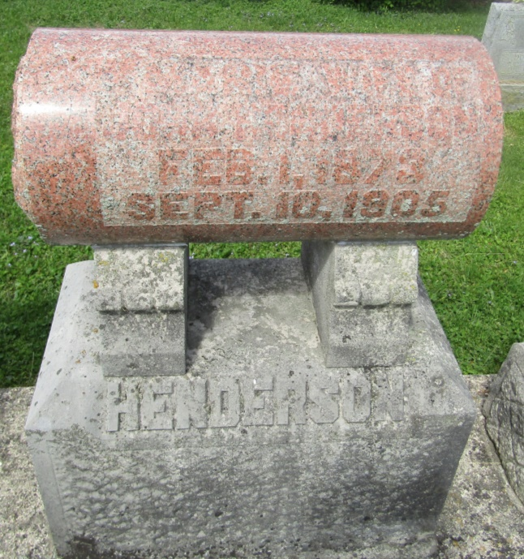

Manie W Henderson
in the Indiana, U.S., Death Certificates, 1899-2011
Name: Manie W Henderson
[Manie W Schooley]
Gender: Female
Race: White
Age: 32
Marital status: Married
Birth Date: 1 Feb 1873
Birth Place: Ind
Death Date: 10 Sep 1905
Death Place: Upland, Grant, Indiana, USA
Father: Geo Schooley
Mother: Mary Ann Pilsher
Spouse: John Henderson
Informant: John Henderson; Upland, Indiana
Burial: September 13, 1905; Asbury Cemetery

