Barbara Ann (Brown) Hardwick
November 22, 1947 – December 16, 2020

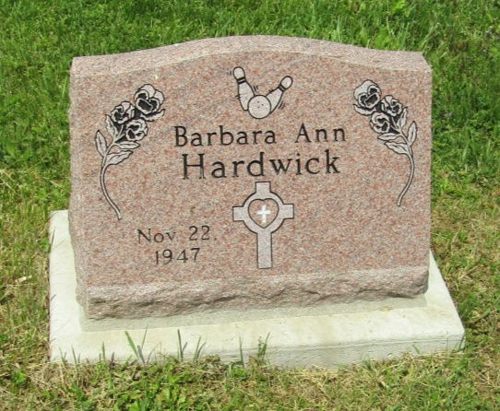

HARTFORD CITY – Barbara “Barb” Ann Hardwick, 73, passed away at 2:40 p.m. Wednesday, December 16, 2020 at IU Health Ball Memorial Hospital.
She was born in Huntington on November 22, 1947 to Ernest Edward Brown and Charlotte Elizabeth (Cree) Bird. Barb graduated from Blackford High School in 1972. She married John Walter Hardwick on December 27, 1986 at the Old Hartford City Wesleyan Church by Rev. Lynn Bruce. John passed away on June 24, 2014.
She retired from St. Joe Container after 32 years of service where she was the Secretary. Barb was a member of Zion Lutheran Church in Hartford City, where she was a Stuart and she tied knots in quilts at church.
Barb was always smiling and she made friends so easily. She had a great personality, was kind and had a heart of gold. She never met a stranger and she enjoyed spending time with her family and friends. One of her greatest pleasures was bowling. She was an avid bowler and was very proud to have had a 298 game in 1973. She bowled a 705 Series and was a member of the Hartford City Bowling Hall of Fame.
She was formerly the secretary and treasurer of the Hartford City Bowling Association for the Twilight League, her dedication had her being the secretary for 40 years. She bowled in the Woman’s National and the National Queen’s Tournament both for eleven years. She had formerly bowled in the Hoosierettes State Tournament and the WPTA Bowler of the Week out of Fort Wayne. Not only was the bowling alley a home away from home, but she could also be found watching the kids play sports in Blackford County. She loved cheering on the Bruins and made it to as many games as she could.
Barb will be sadly missed by her son, Robert “Bob” J. (wife, Teresa) Banter of Hartford City; grandsons, Griffin J.T. Banter and Grant R. Banter; brothers, Jerry J. (wife, Beth) Brown of Montpelier, Jim E. (wife, Sheryl) Brown of Bluffton and John F. Brown of Warren; several nieces and nephews. She is also preceded in death by her father, Ernest E. Brown, mother, Charlotte Elizabeth Bird and step-father, Alfred Bird.
Funeral service for Barb will be private and burial will be at Asbury Cemetery. Memorials may be made to American Lung Association, P.O. Box 7000, Albert Lea, MN 56007-8001 or Blackford County Community Foundation-Cancer Services, P.O. Box 327, Hartford City, IN 47348.

Keplinger Funeral Home, Blackford County, Indiana
December 17, 2020

