Thelma Louise (Stephenson) Banter-Guntharp
December 18, 1914 – September 6, 1993

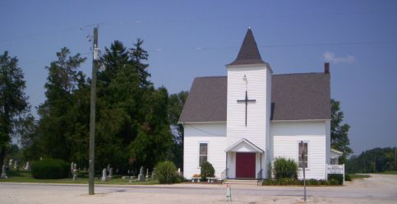
Photo by Barbara Baker Anderson

Thelma L Guntharp
in the Indiana, U.S., Death Certificates, 1899-2011
Name: Thelma L Guntharp
[Thelma L Stephenson]
Gender: Female
Race: White
Age: 79
Marital status: Widow
Birth Date: 18 Dec 1914
Birth Place: Indiana
Death Date: 6 Sep 1993
Death Place: Hartford, Blackford, Indiana, USA
Father: Benjaman Stephenson
Mother: Eva May
Informant: Robert D. Banter; son; Montpelier, Indiana
Burial: September 9, 1993; Asbury Cemetery; Wells County, Indiana

