William Griffith
February 28, 1803 – September 10, 1870

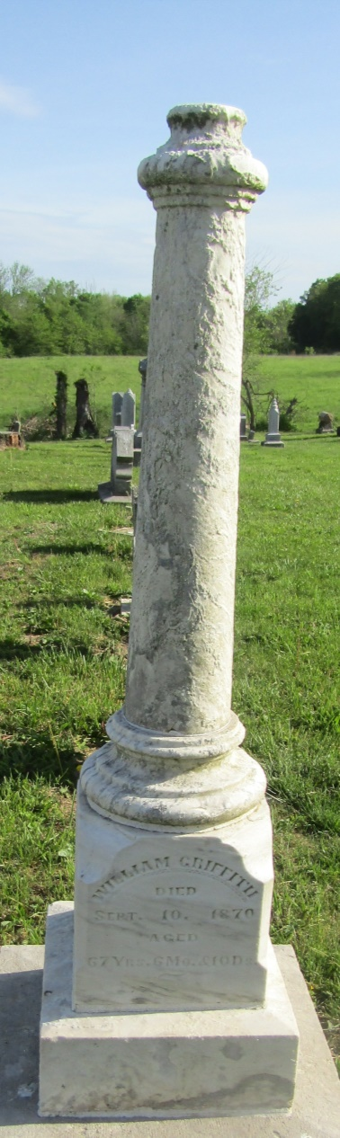

No further information found at this time

