Martha Delores Griffith
December 11, 1913 – December 2, 1993

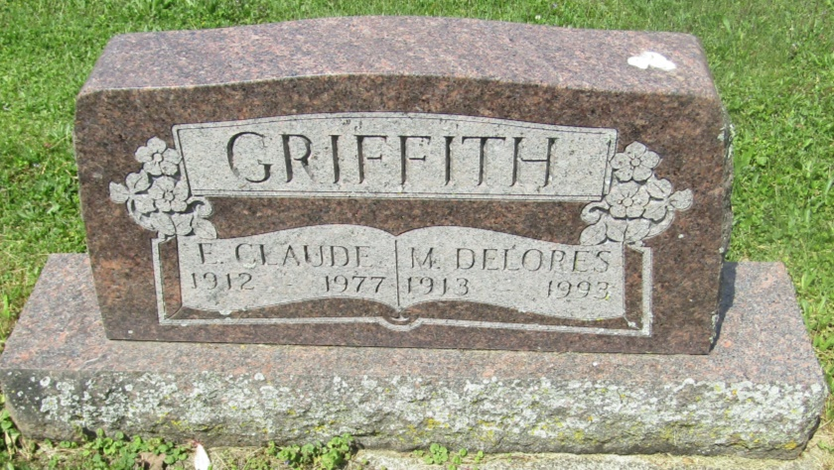

Martha Delores Griffith
in the Florida, U.S., Death Index, 1877-1998
Name: Martha Delores Griffith
Race: White
Age at Death: 79
Birth Date: 11 Dec 1913
Death Date: 2 Dec 1993
Death Place: Polk, Florida, United States
*****

U.S., Social Security Death Index, 1935-2014
Name: Martha D. Griffith
Social Security Number: xxx
Birth Date: 11 Dec 1913
Issue Year: 1959-1960
Issue State: Indiana
Last Residence: 33844, Haines City, Polk, Florida, USA
Death Date: 2 Dec 1993

